**Final Project Reflection**

At the beginning of class, students were tasked with choosing a scene to reconstruct in a 3D environment. Instead of simply selecting items from around my home, I wanted the image to have a theme. That proved a bit harder than I first imagined. I needed four objects which I could recreate using different primitive shapes, and at least one had to be complex, composed of two primitives. After much deliberation, I chose the coffee scene.

Every week, I learned something new that helped me build my finished scene. The first week, I learned to draw 2D triangles, which was the basis for the counter. The weekly tutorials illustrated how to construct a cube which I remodeled into a pyramid. Next, I learned how to texture objects and add lights to the scene. Using code developed by Michal Bubnár (2021), I successfully added cylinders and spheres to my project. Without his code for building primitives, I do not believe I would have finished some of my objects. In addition, Mr. Bubnár’s tutorials were remarkably beneficial.

The application features built-in navigation controls to explore the environment. The camera is from the user’s perspective, and a mouse and standard WSAD keys allow the user to move throughout the scene. Furthermore, the user can look up (Q) or down (E) or toggle between perspective and orthogonal view (P). Esc leaves the scene.

Following best practices, the functions are modular and well organized with appropriate whitespace (University of Colorado, n.d.). That not only makes the code easier to read but allows for porting to a different application (Rana, 2021). Comprehensive documentation offers insight into what each section does and makes the code simple to reuse.

I struggled with this course and spent countless hours on every assignment. However, I am still interested and plan to continue my training as I have time. My project is not perfect. I could not create only half of the sphere, so my coffee scoop can be seen beneath the counter. In addition, I could not get an image to clamp to a cylinder correctly. Therefore, I created vertical planes to give the illusion of the labels. I then rotated and scaled the graphics into place. While not perfect, I am proud of what I created and think objects with illumination and textures are representative of the actual scene. I am particularly proud that I was finally able to orient the image on the filter box correctly.

**References**

Bubnár, M. [ michalbb1]. (2021, February 13). *opengl4-tutorials-mbsoftworks/common_classes/static_meshes_3D/primitives at master · michalbb1/opengl4-tutorials-mbsoftworks* [GitHub Repository]. GitHub. <https://github.com/michalbb1/opengl4-tutorials-mbsoftworks/tree/master/common_classes/static_meshes_3D/primitives>

Rana, V. (2021, May 29). *Coding Standards and Best Practices*. Kodementor. <https://kodementor.com/coding-standards-and-best-practices/>

University of Colorado. (n.d.). *Coding Best Practices*. Research Computing University of Colorado, Boulder. Retrieved August 20, 2021, from <https://curc.readthedocs.io/en/latest/programming/coding-best-practices.html>

**Actual Scene**

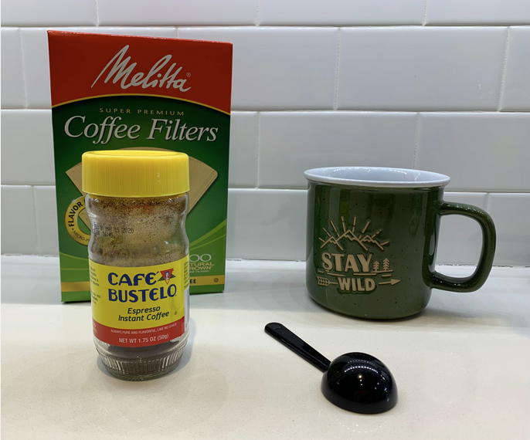 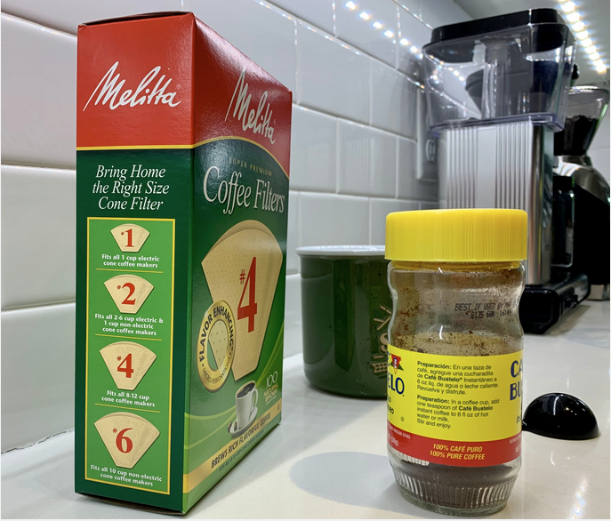

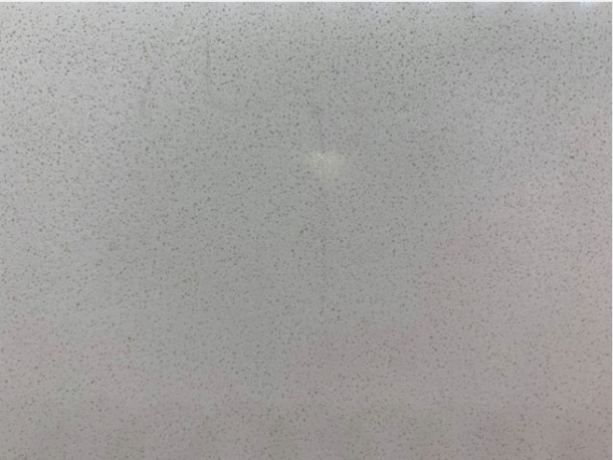

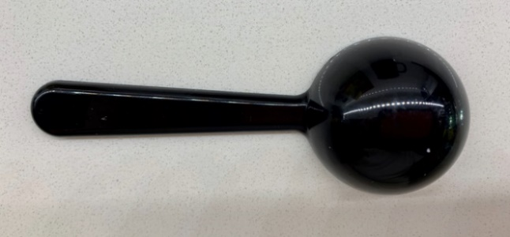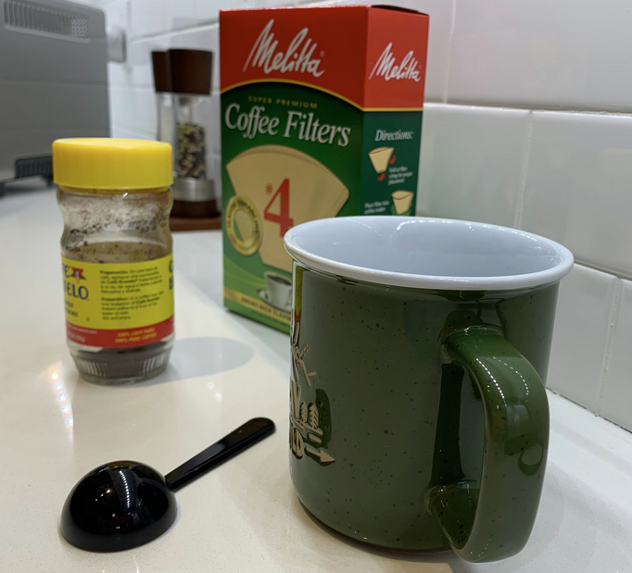

**Recreated Scene**

